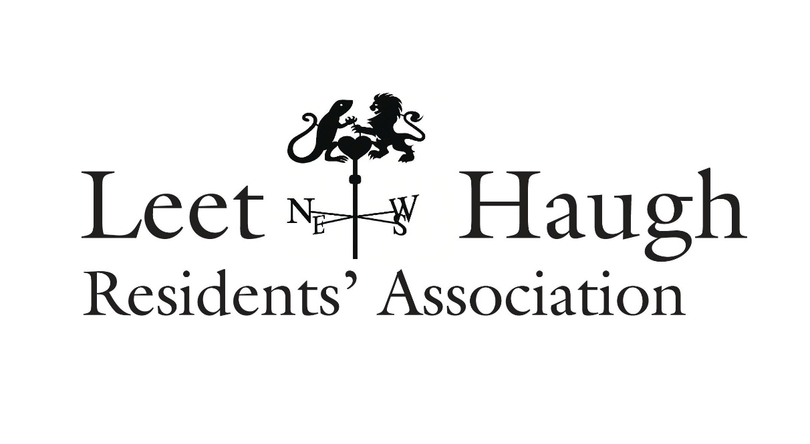
Hello to all the residents of Leet Haugh and welcome to your new look newsletter

AGM
At the AGM of the Residents Association in September 2025 a new committee was elected to assist all residents and liaise with the factor for the development, FBR Seed.

New committee: John Burgon (chair), Trish Burgon (secretary), Jennie Milne, Joan Cowley, Ruth Dickinson. There is room for one more, so if you’d like to join us, please do get in touch.
Tpoics discussed at the last committee meeting in November included:
Road safety issues and signage, the state of the building site, street lighting and the gardening contract.
Please note the new email address for any communication is now leethaugh@gmail.com
The old email address is now closed. If you are no longer resident in Leet Haugh, please let us know and we will take you ff the circulation list for the newsletter.
Fort communications with the factor please use factoring@fbrseed.com

Website
Were you aware of the website for the development? Leethaugh.com The website currently has basic information about Leet Haugh, but we have made a start on updating it and hope to include information that might be useful, particularly for new arrivals. Did you know for example, that you can arrange to have milk or papers delivered? Perhaps we could include a list of tradespeople recommended by residents? Let us have your ideas.
If you have any suggestions, please let us know via leethaugh@gmail.com

Christmas Lights
We hope you like what we have done with the Christmas Lights on the corner of the green this year. Our thanks go to the Letham family for their time and fork lift skills and to everyone who helped the committee with this job including, Colin, Susan and Alan, Peter and Margaret. For next year we will be replacing the lights that hang on the wall but any other suggestions you may have will be welcome – as will volunteers!
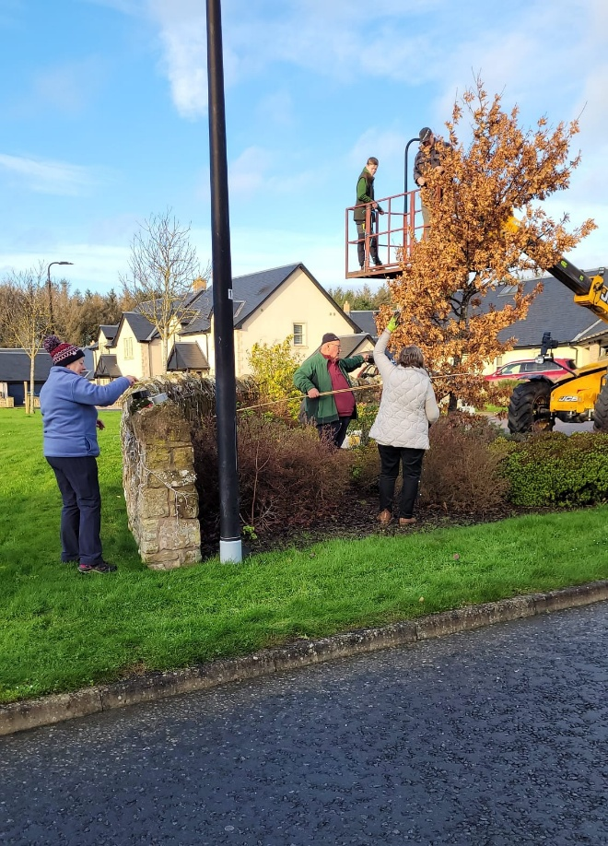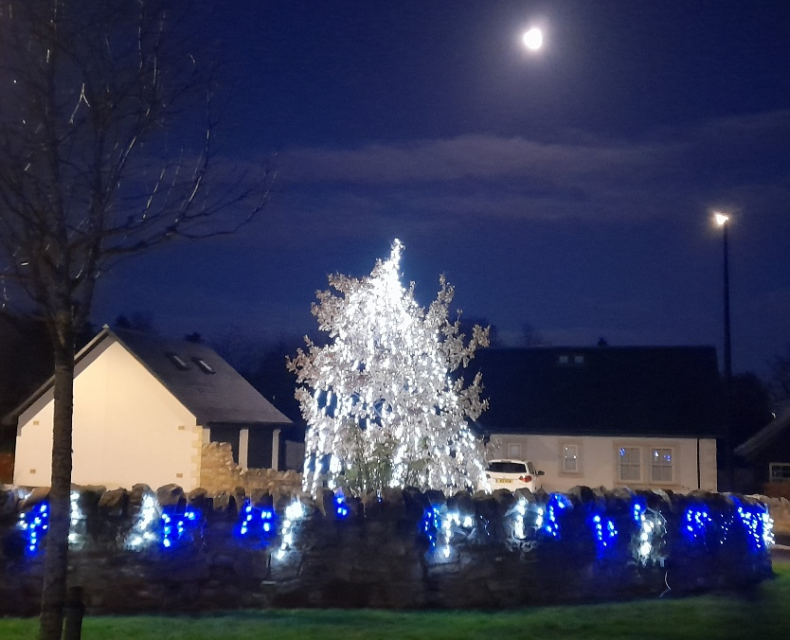


Christmas Quiz
- What beverage company has used Santa Claus in its advertising since 1931?
- Which one of Santa’s reindeer has the same name as a god of love?
- How do you say Merry Christmas in Spanish?
- Which ocean can Christmas Island be found in?
- Which fast food chain is a popular choice for Christmas dinner in Japan
- How many ghosts show up in A Christmas Carol?
- Die Hard takes place on Christmas Eve, but in which city?
Answers at the bottom of the page.

We will sign off by wishing all of you a very happy Festive Season



Christmas Quiz Answers

1 Coca Cola 2 Cupid 3 Feliz Navidad 4 Indian Ocean 5 KFC 6 Four 7 Los Angeles

