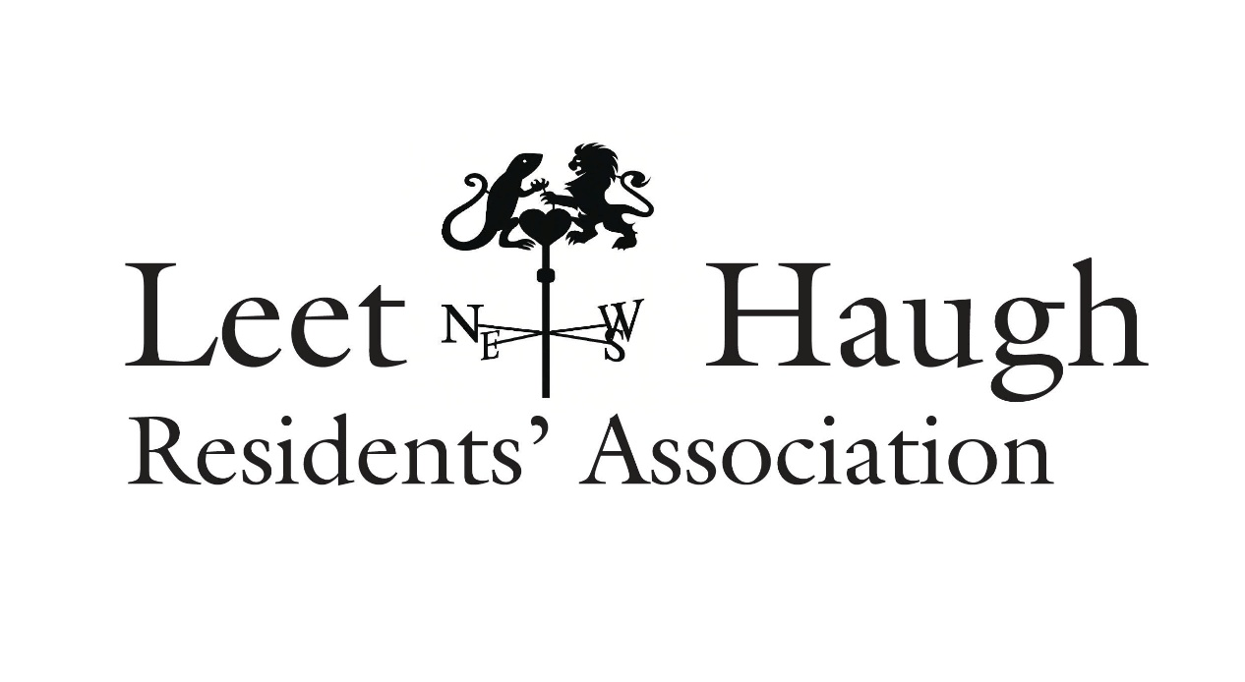

Hello to all residents of Leet Haugh and welcome to your Spring newsletter!
At the AGM of the Residents’ Association in September 2025 a new committee was elected
to assist owners and residents and to liaise with the factors for the development, FBR Seed.
Your committee is now at full strength:
John Burgon (chair), Trish Burgon (secretary), Jennie Milne,
Joan Cowley, Ruth Dickinson, Margaret Greenwood
The email address for any communications is leethaugh@gmail.com
If you are no longer resident in Leet Haugh, please let us know and we will take you off the circulation list for the newsletter.
For communications with the factor, please use factoring@fbrseed.com

Website
The website for the development can be found at Leethaugh.com
It currently has basic information about Leet Haugh but we have made a start on updating it and hope to include information that might be useful, particularly for new arrivals.
If you have any suggestions, please let us know via leethaugh@gmail.com

Areas of concern
We have met with the factor twice since the start of the year to raise matters of concern:
Road safety issues
*The state of the building site at the top of the hill
*The appalling state of the fence behind Cospatrick Court
*The street lights in Dunglass Road
Rodent issue
*The lack of a pavement at the top of the green
Several of the above matters (indicated with *) fall within the remit of D & A Estates and it is apparent that they are slow to respond, despite repeated requests. This is the current state of things:

Road safety
We are concerned that there is a distinct possibility of an accident at the junction of Cospatrick Court, Dundock Drive and Lambton Green. Parked cars on the roadway at the corner, in what is essentially a passing place, are restricting visibility and forcing cars exiting the development to pull onto the wrong side of the road to do so.
In recent weeks the situation has improved a bit but we shall continue to monitor things. We are fortunate that there has not yet been a collision, but if necessary, we may have to involve the SBC Roads Department to see what can be done to make this area safer for drivers and pedestrians.
We also want to take this opportunity to appeal to all residents for the benefit of everyone to only park in their allotted spaces and where those are not sufficient for their requirements, to use the numerous visitor parking spaces instead. The development was designed with narrow roads and passing places as a traffic calming measure. If we use the designated passing places for parking cars the system does not function properly. The last thing we all want is to see yellow lines.

The building site
This has been in a disgraceful state since building works came to a halt. There has been some minor activity over the last few weeks and we must hope that the tidying up will continue. A sewage smell has been mentioned by residents and this has also been reported to D & A Estates by the factor. Ideally, the left-over building materials would be removed, or stored at the far side of the site and the storage containers should be removed.

The fence along the rear of Cospatrick Court
We have made several requests for the rickety metal fencing to be removed and replaced with the same wooden fencing that was installed at the top of Dunglass Road. This should be taken right along towards the road. The matter is with D & A Estates.

Dunglass Road street lighting
Several of the street lamps have been out of action since January. This area has yet to be adopted by SBC and therefore any repair is the responsibility of D & A Estates/ Hudson Hirsel. Despite repeated requests, they have yet to take action but we will continue to press.

Rodent issue
Some residents reported seeing rats in their gardens at the end of January. At that time, it became apparent that someone – perhaps a dog walker from elsewhere - was leaving out food in the wood along the side of the development. Mostly vegetable scraps but also come cooked food. We put up a couple of signs to ask people not to leave anything that might attract rats and the situation appears to have improved. Do let us know if any of you still have an issue.

Top of the green – lack of pavement
Another safety issue here, as the developers’ plans did not include a footpath along the top of the green. As a result, parents with small children / prams, school kids and anyone using a mobility scooter has to use the roadway. We will see if anything can be done to rectify this.
We are aware that previous committees have tried to rectify some of these matters and we will continue to try to do the same. It is a considerable frustration that the factors have not achieved any constructive dialogue with D & A Estates to date to resolve any of the issues raised.

